# Creating and using a backup

The management has understood that the backup of the database allows the data to be recovered when the primary storage failure due to medium failure, accidental deletion or malicious attack etc. You are required to suggest SAMS the follow ways to protect data from being lost:

1. List two ways of SAMS can back up the database physically.
2. File system backup, create another copy of the system files that contain the database.
3. Create a full copy of the main database that is used in case the main database is corrupted.
4. List at least two ways of SAMS can back up the database logically.
5. Using workbench to create a data export of the database.
6. Database dump, using a batch file create a dump of the full database.
7. There are some database tables that are relatively static in nature such as the aircraft model technical information and technician information which are quite important to the airport operation. The management would like to have the database backup regularly and recover quickly even they may not be up-to-date. The management indicated that the operation is tolerable if those information are three days old.
8. Write backup commands (i.e. in batch file) to conduct the full backup of the database including the following requirements:

* The backup file name must include the disk directory and with date & time as part of it.
* Suggest when to do this backup. (i.e. day/time)
  + 5pm
* How often this backup method be repeated?
  + Every 3 days

Capture the screen shots with the commands executed successfully.

@echo off

for /f "tokens=2-4 delims=/ " %%a in ('date /t') do (set mydate=%%c%%a%%b)

for /f "tokens=1-2 delims=/:" %%a in ("%TIME%") do (set mytime=%%a%%b)

mysqldump -u root -p sams > C:\mysql_backup\C_%mydate%_%mytime%.sql

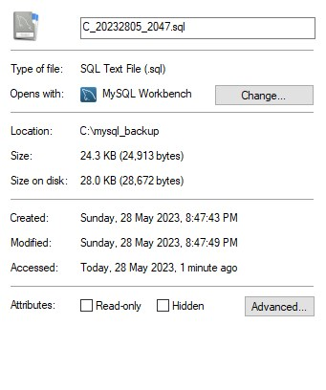

1. Write a sql command to recover the technician table from the backup file. Hints: need to turn off the database referential integrity and drop the Technician table before the recovery of the Technician table.

Capture a screen shot the Technician table as been dropped.

Capture another screen shot with the sql recovery commands executed successfully.



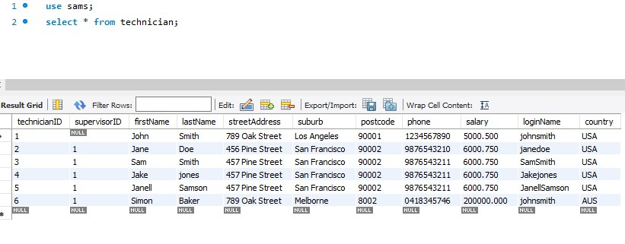

mysql -u root -p --database=sams --table=technician <C:\mysql_backup\[backup name].sql